Dining Reservation Chatbot

1. Introduction
Manual table booking in restaurants often leads to overbooking, long waitlists, and customer dissatisfaction. This project implements a console-based dining reservation chatbot that automates table booking, manages waitlists, previews menu and policies, and sends confirmation messages (simulated). The system improves booking efficiency and reduces operational overhead.
2. Objectives
- To build a chatbot that interacts continuously with users via terminal
- To automate table booking using simple table optimization
- To manage waitlists when tables are unavailable
- To compress menu and policy data using ScaleDown
- To simulate SMS notifications for confirmations
- To provide a live dashboard of reservations and waitlist
3. System Overview
The system is a Python-based console chatbot that runs in a loop until the user exits. It accepts user commands to book tables, view menu/policy, and check reservation status. A simple algorithm assigns the best-fit table based on party size. When tables are full, users are added to a waitlist.
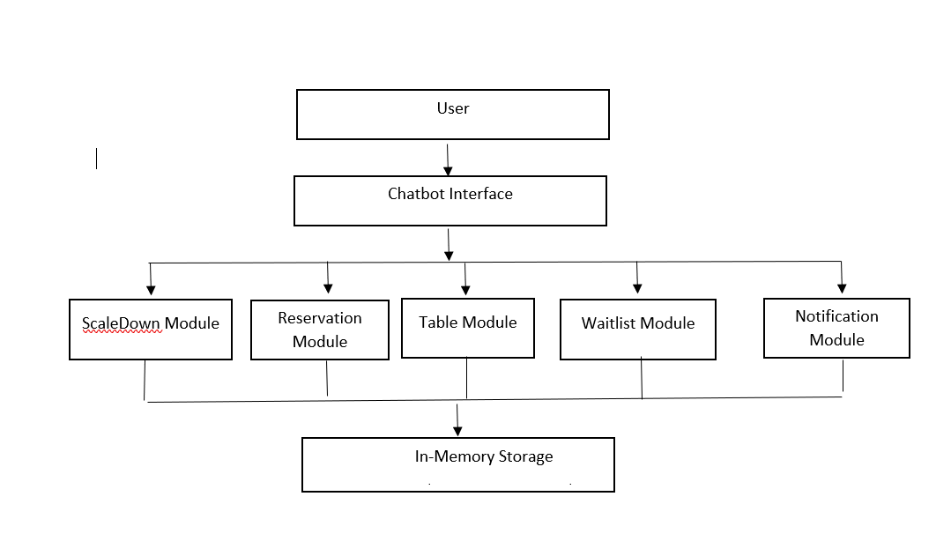 fig 1: System Architecture Diagram

4. Architecture (Textual)
User (Terminal)
→ Chatbot Interface
→ Reservation Module
→ Table Optimization Module
→ Waitlist Manager
→ ScaleDown Module
→ SMS Notification (Mock Output)

5. Modules Description
5.1 Chatbot Interface
Handles user input in a continuous loop and routes commands (menu, book, status, exit) to appropriate modules.
5.2 Reservation Module
Books tables based on availability and stores reservation details such as name, phone, party size, time, and dietary requests.
5.3 Table Optimization Module
Selects the smallest suitable table for the given party size to reduce wastage and increase table turnover.
5.4 Waitlist Management
If no suitable table is available, the user is added to a waitlist and notified.
5.5 ScaleDown Module
Compresses long menu and policy text into short summaries to improve response speed and readability.
5.6 Notification Module (Mock SMS)
Simulates SMS notifications by printing confirmation messages to the terminal.

6. Algorithm
Table Allocation Algorithm (Best-Fit):
- Store available table sizes.
- Filter tables that can fit the party size.
- Select the smallest suitable table.
- If no table fits, add the user to the waitlist.

7. Input and Output
Input:
- User commands (menu, book, status, exit)
- Reservation details (name, phone, party size, time, dietary)
Output:
- Booking confirmation or waitlist message
- Menu and policy preview (compressed)
- Reservation and waitlist dashboard
- SMS confirmation (simulated output)

8. Results
The chatbot successfully books tables, manages waitlists, and displays real-time reservation status. ScaleDown compression reduces menu and policy text size, improving response speed. SMS notifications provide user feedback for confirmations.

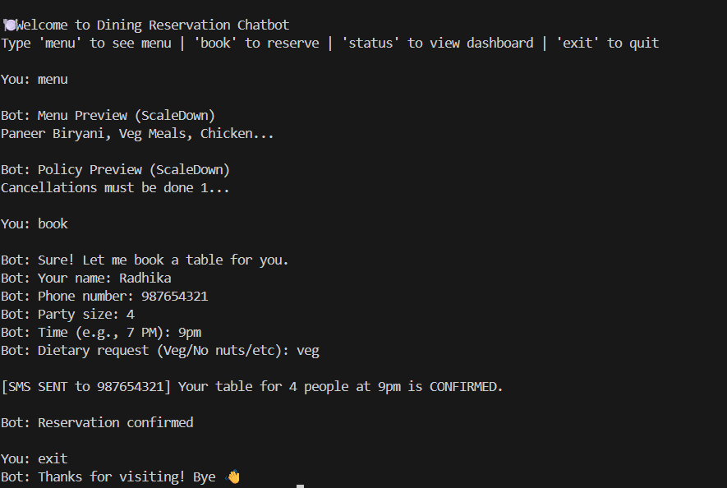
fig 2:Dining Reservation Chatbot Interface

9. Limitations
- No real-time integration with OpenTable or Resy
- SMS notifications are simulated
- Console-based interface only
- Table availability is static (no real-time updates)

10. Future Enhancements
- Integration with real reservation platforms (OpenTable/Resy)
- Real SMS/WhatsApp notifications
- Web or mobile interface
- Auto-promotion from waitlist
- Analytics for bookings, no-shows, and table turnover

11. Conclusion
This project demonstrates how a simple chatbot can automate dining reservations, optimize table usage, manage waitlists, and improve customer interaction. The console-based implementation serves as a strong foundation for building scalable, real-world reservation systems.

